欢迎光临Aleinu温室。这个别具一格的以色列高科技农业种植园设在屋顶，地势极佳，位于朱迪亚沙漠北部，与耶路撒冷毗邻，四周尽是乡间美景。温室之行包括一场专业讲座，介绍以色列农业生产中采用的先进科技；还能品尝新鲜蔬菜，购买温室农产品，甚至有天然草药。但Aleinu的独特之处在于，它不只是以色列普通的高科技温室，还是新型城市工农业技术生产商。Aleinu温室正在努力向以色列展示关于人类未来的全新概念，尤其强调环保原则。为此，Aleinu的主要目标之一就是推广“生态城市农业”运动。你可能会问：“这对缓解温室效应有何作用？”快到Aleinu温室去找答案吧！
YouTube link
1hr-1.5 hrs tours.
For more details and reservations, or for other attractions or tour destinations, feel free to call Netanel at +972-543316613 or Netanel@keshet.me. www.keshet.me

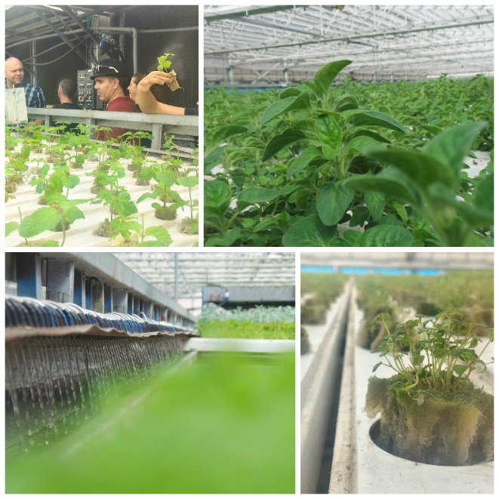
Welcome to the "Aleinu" greenhouse. The unique high-technology Israeli agricultural plant is settled on the roof in a gorgeous location, in the Northern Judean Desert near Jerusalem and abounds with the beautiful panorama of the countryside. Your visit to the greenhouse is accompanied by a professional lecture on the advanced technologies of agricultural production in Israel. The visit to the greenhouse includes the degustation of the fresh-grown greens, the possibility of acquiring the greenhouse production, which includes even the natural medical herbs. Nevertheless, the special thing about "Aleinu" is that it is not only a usual high-tech Israeli greenhouse; it is the manufacturer of new urban industrial agricultural technologies. Greenhouse "Aleinu" is trying to present the Israeli society the completely new conception of the possible future for humanity. "Aleinu" strongly claim their principles on the issues of environment protection, and for this reason, one of the main objectives of "Aleinu's" work is to promote the Ecological Urban Agriculture movement. You may ask, "How can this help stop the greenhouse effect"? Go find out in the "Aleinu" greenhouse!

